Business CareWare


How To Install and Setup CABS AutoEmail for Testing
How To Document

Document Changes

Date | Version | Change Description | Changed By
30/11/2016 | 1.0 | Original Version | TT

Table of Contents
1 Introduction 3
2 Create Test Database 3
2.1 Clean Database for Testing 3
2.2 Ensure CABS Console Connectivity to Test Database 3

Introduction

This document provides a description of how to install and setup CABS Autoemail for testing. This is for internal use and is not a customer site setup (although there could be similarities). The document assumes MS SQL Database Mail is already configured.

Where possible every effort should be made to ensure the testing environment mirrors the target delivery environment. Failure to do so could result in difficulties further down the line.

Create Test Database

Clean Database for Testing

A clean database should be restored side by side the development database.

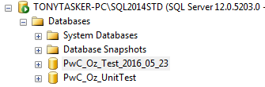
Figure 1 – Database PwC_Oz_UnitTest Created for Testing

Any issues that arise during testing that were not found during development can be investigated on the development database.

Ensure CABS Console Connectivity to Test Database

Create a CABS UDL file

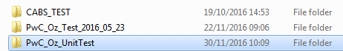

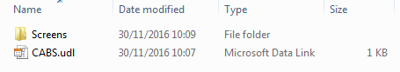
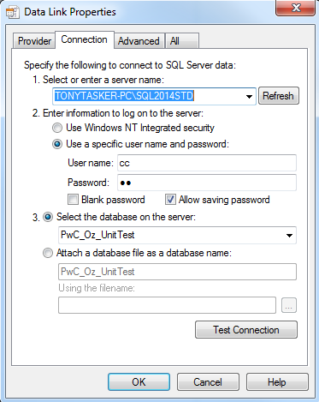

Test the connection and ensure that it works correctly.

Using the CABS Switcher program (running as Administrator) create a new Database shortcut pointing to the test database.

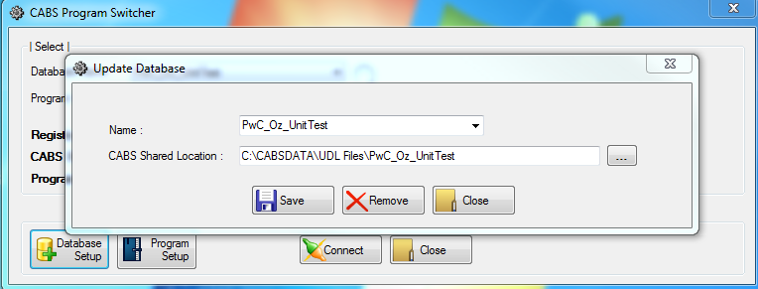

Run CABS (from the CABS Switcher program) ensuring that the correct console version is used.

Ensure that CABS can be logged into and that the correct components are being used. This can be checked using the “Executable Details” menu option on the “System” dropdown menu:

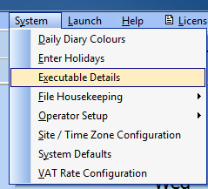

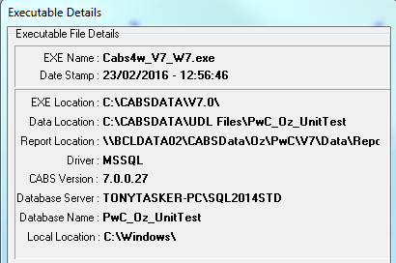

Installation of CABS AutoEmail

- All scripts SQL scripts should be copied to an installation directory

- Some scripts must be edited before they are run:

  - 18. Auto-Emailer Session Check.sql – Replace the text <<Put YOUR DB Name in Here>> and <<PUT THE LOGIN to run the job HERE>> with appropriate details

  - 19. Auto-Emailer Recurring Emails Check.sql

  - 20. Auto-Emailer AEF_LINK Delete.sql

  - AutoEmail_Install.sql – Add the SQL ServerName, Databasename and Filepath in the script indicated by the text ‘*** INSERT xxxx ***’. Remember to end the filepath with a backslash.

- The install script uses xp_cmdshell which is not always enabled on a SQL Server.

  - Check if xp_cmdshell is enabled by running the following SQL:
SELECT CONVERT(INT, ISNULL(value, value_in_use)) AS config_value
FROM sys.configurations
WHERE name = 'xp_cmdshell' or name = 'show advanced options';

If the result is as below:

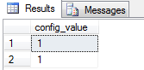

The installation script can be run.

If not run the following SQL:

EXEC sp_configure 'show advanced options', 1
GO
RECONFIGURE
GO

EXEC sp_configure 'xp_cmdshell', 1
GO
RECONFIGURE
GO

  - Open the AutoEmail_Install.sql file in MS SQL Server Management Studio, ensure that the connection is with the appropriate database and execute the script.

  - The Messages Tab will display progress information and whether or not the script ran successfully:

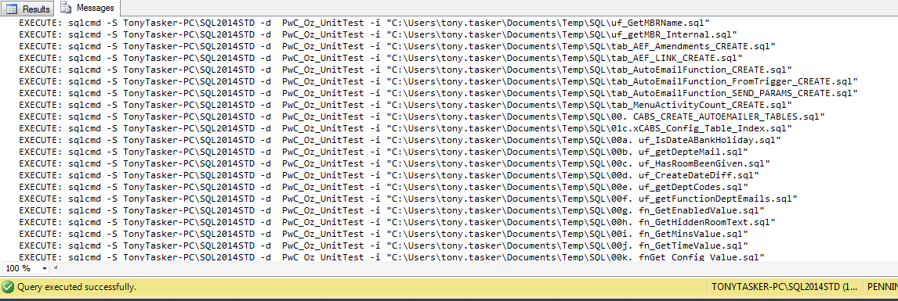

  - The Result Tab will display diagnostic information and should be checked to see if there are any errors or issues (such as dependency problems):

StatusMessage
uf_GetMBRName: Dropped Function uf_GetMBRName
uf_GetMBRName: Creating Function uf_GetMBRName
uf_getMBR_Internal: uf_Guf_getMBR_Internal - Does Not Already Exist !
uf_getMBR_Internal: Creating Function uf_Guf_getMBR_Internal
tab_AEF_Amendments_CREATE: Table AEF_Amendments Created
tab_AEF_LINK_CREATE: Table AEF_LINK Created
tab_AEF_LINK_CREATE: INDEX - ix_Config_SessNo_EmailType_Sent Already Exists !
tab_AEF_LINK_CREATE: Created Index - ix_Config_SessNo_EmailType_Sent
tab_AEF_LINK_CREATE: INDEX - ix_Config_FREF_EmailType Already Exists
tab_AEF_LINK_CREATE: Created Index - ix_Config_FREF_EmailType
tab_AutoEmailFunction_CREATE: Table AutoEmailFunction Created
tab_AutoEmailFunction_FromTrigger_CREATE: Table AutoEmailFunction_FromTrigger Created
tab_AutoEmailFunction_SEND_PARAMS_CREATE: Table AutoEmailFunction_SEND_PARAMS Created
tab_MenuActivityCount_CREATE: Table MenuActivityCount Created
00. CABS_CREATE_AUTOEMAILER_TABLES: CABS_CREATE_AUTOEMAILER_TABLES - Does Not Already Exist !
00. CABS_CREATE_AUTOEMAILER_TABLES: Creating Procedure CABS_CREATE_AUTOEMAILER_TABLES
00. CABS_CREATE_AUTOEMAILER_TABLES: Executing Procedure CABS_CREATE_AUTOEMAILER_TABLES
01c.xCABS_Config_Table_Index: INDEX ix_Config_Type_Section_Deleted ON [dbo].[xCABS_CONFIG_TABLE] Does Not Exist !
01c.xCABS_Config_Table_Index: Creating INDEX ix_Config_Type_Section_Deleted ON [dbo].[xCABS_CONFIG_TABLE]
01c.xCABS_Config_Table_Index: INDEX ix_Config_Type_Section_Key_Deleted ON [dbo].[xCABS_CONFIG_TABLE] Does Not Exist !
01c.xCABS_Config_Table_Index: Creating INDEX INDEX ix_Config_Type_Section_Key_Deleted ON [dbo].[xCABS_CONFIG_TABLE]
00a. uf_IsDateABankHoliday: Dropped Function uf_IsDateABankHoliday
00a. uf_IsDateABankHoliday: Creating Function uf_IsDateABankHoliday
00b. uf_getDepteMail: uf_getDepteMail - Does Not Already Exist !
00b. uf_getDepteMail: Creating Function uf_getDepteMail
00c. uf_HasRoomBeenGiven: uf_HasRoomBeenGiven - Does Not Already Exist !
00c. uf_HasRoomBeenGiven: Creating Function uf_HasRoomBeenGiven
00d. uf_CreateDateDiff: uf_CreateDateDiff - Does Not Already Exist !
00d. uf_CreateDateDiff: Creating Function uf_CreateDateDiff
00e. uf_getDeptCodes: uf_getDeptCodes - Does Not Already Exist !
00e. uf_getDeptCodes: Creating Function uf_getDeptCodes
00f. uf_getFunctionDeptEmails: uf_getFunctionDeptEmails - Does Not Already Exist !
00f. uf_getFunctionDeptEmails: Creating Function uf_getFunctionDeptEmails
00g. fn_GetEnabledValue: fn_GetEnabledValue - Does Not Already Exist !
00g. fn_GetEnabledValue: Creating Function fn_GetEnabledValue
00h. fn_GetHiddenRoomText: Dropped Function fn_GetHiddenRoomText
00h. fn_GetHiddenRoomText: Creating Function fn_GetHiddenRoomText
00i. fn_GetMinsValue: Dropped Function fn_GetMinsValue
00i. fn_GetMinsValue: Creating Function fn_GetMinsValue
00j. fn_GetTimeValue: Dropped Function fn_GetTimeValue
00j. fn_GetTimeValue: Creating Function fn_GetTimeValue
00k. fnGet_Config_Value: Dropped Function fnGet_Config_Value
00k. fnGet_Config_Value: Creating Function fnGet_Config_Value
00l. uf_IsSendableSessBooking: uf_IsSendableSessBooking - Does Not Already Exist !
00l. uf_IsSendableSessBooking: Creating Function uf_IsSendableSessBooking
00m. uf_GetEmailEarlyCutOff: uf_GetEmailEarlyCutOff - Does Not Already Exist !
00m. uf_GetEmailEarlyCutOff: Creating Function uf_GetEmailEarlyCutOff
00n. uf_getExtraDescription: uf_getExtraDescription - Does Not Already Exist !
00n. uf_getExtraDescription: Creating Function uf_getExtraDescription
00o. uf_getMenuItemDescription: uf_getMenuItemDescription - Does Not Already Exist !
00o. uf_getMenuItemDescription: Creating Function uf_getMenuItemDescription
00p. utf_DrinkTrolleyView: utf_DrinkTrolleyView - Does Not Already Exist !
00p. utf_DrinkTrolleyView: Creating Function utf_DrinkTrolleyView
00q. utf_MenuView: utf_MenuView - Does Not Already Exist !
00q. utf_MenuView: Creating Function utf_MenuView
00r. utf_PackageView: utf_PackageView - Does Not Already Exist !
00r. utf_PackageView: Creating Function utf_PackageView
00s. uf_GetMenuItemCount: uf_GetMenuItemCount - Does Not Already Exist !
00s. uf_GetMenuItemCount: Creating Function uf_GetMenuItemCount
02. uf_AEF_Link_Sendable: uf_AEF_Link_Sendable - Does Not Already Exist !
02. uf_AEF_Link_Sendable: Creating Function uf_AEF_Link_Sendable
03. uf_GetEmailSendTime: Dropped Function uf_GetEmailSendTime
03. uf_GetEmailSendTime: Creating Function uf_GetEmailSendTime
04. uf_GetEmailSendType: uf_GetEmailSendType - Does Not Already Exist !
04. uf_GetEmailSendType: Creating Function uf_GetEmailSendType
04a.uf_Get_FirstName_From_CT_DESC: uf_Get_FirstName_From_CT_DESC - Does Not Already Exist !
04a.uf_Get_FirstName_From_CT_DESC: Creating Function uf_Get_FirstName_From_CT_DESC
04b.uf_Get_LastName_From_CT_DESC: uf_Get_LastName_From_CT_DESC - Does Not Already Exist !
04b.uf_Get_LastName_From_CT_DESC: Creating Function uf_Get_LastName_From_CT_DESC
04c.uf_Get_TelNo_From_CT_DESC: uf_Get_TelNo_From_CT_DESC - Does Not Already Exist !
04c.uf_Get_TelNo_From_CT_DESC: Creating Function uf_Get_TelNo_From_CT_DESC
04d.uf_Get_EC_Email: uf_Get_EC_Email - Does Not Already Exist !
04d.uf_Get_EC_Email: Creating Function uf_Get_EC_Email
04e.uf_Get_Acc_Man_Email: uf_Get_Acc_Man_Email - Does Not Already Exist !
04e.uf_Get_Acc_Man_Email: Creating Function uf_Get_Acc_Man_Email
04e.uf_Get_Acc_Man_FirstName: uf_Get_Acc_Man_FirstName - Does Not Already Exist !
04e.uf_Get_Acc_Man_FirstName: Creating Function uf_Get_Acc_Man_FirstName
04e.uf_Get_Acc_Man_LastName: uf_Get_Acc_Man_LastName - Does Not Already Exist !
04e.uf_Get_Acc_Man_LastName: Creating Function uf_Get_Acc_Man_LastName
04e.uf_Get_Acc_Man_Telephone: uf_Get_Acc_Man_Telephone - Does Not Already Exist !
04e.uf_Get_Acc_Man_Telephone: Creating Function uf_Get_Acc_Man_Telephone
04e.uf_Get_EC_LastName: uf_Get_EC_LastName - Does Not Already Exist !
04e.uf_Get_EC_LastName: Creating Function uf_Get_EC_LastName
04e.uf_Get_EC_Telephone: uf_Get_EC_Telephone - Does Not Already Exist !
04e.uf_Get_EC_Telephone: Creating Function uf_Get_EC_Telephone
04f.uf_Get_EC_FirstName: uf_Get_EC_FirstName - Does Not Already Exist !
04f.uf_Get_EC_FirstName: Creating Function uf_Get_EC_FirstName
05. ufAEF_MatchCriteria: ufAEF_MatchCriteria - Does Not Already Exist !
05. ufAEF_MatchCriteria: Creating Function ufAEF_MatchCriteria
uf_AEF_Is_Within_Send_Window: uf_AEF_Is_Within_Send_Window - Does Not Already Exist !
uf_AEF_Is_Within_Send_Window: Creating Function uf_AEF_Is_Within_Send_Window
06.uf_Get_AEF_EnabledSwitch: uf_Get_AEF_EnabledSwitch - Does Not Already Exist !
06.uf_Get_AEF_EnabledSwitch: Creating Function uf_Get_AEF_EnabledSwitch
06. vw_AEFLink: View vw_AEFLink Does Not Exist !
06. vw_AEFLink: Creating View vw_AEFLink
06a. vw_Extras: Dropped View vw_Extras
06a. vw_Extras: Creating View vw_Extras
06b. vw_PackCodeDept: View vw_PackCodeDept Does Not Exist !
06b. vw_PackCodeDept: Creating View vw_PackCodeDept
06c. vw_Packages: View vw_Packages Does Not Exist !
06c. vw_Packages: Creating View vw_Packages
06d. vw_Menus: View vw_Menus Does Not Exist !
06d. vw_Menus: Creating View vw_Menus
06e. vw_DTCodeDept: View vw_DTCodeDept Does Not Exist !
06e. vw_DTCodeDept: Creating View vw_DTCodeDept
06f. vw_DrinkTrolley: View vw_DrinkTrolley Does Not Exist !
06f. vw_DrinkTrolley: Creating View vw_DrinkTrolley
06g. vw_ExtraCodeDept: View vw_ExtraCodeDept Does Not Exist !
06g. vw_ExtraCodeDept: Creating View vw_ExtraCodeDept
06h. vw_FunctionCostCentres: View vw_FunctionCostCentres Does Not Exist !
06h. vw_FunctionCostCentres: Creating View vw_FunctionCostCentres
06i. vw_ExtrasAmendDel: View vw_ExtrasAmendDel Does Not Exist !
06i. vw_ExtrasAmendDel: Creating View vw_ExtrasAmendDel
00a. sp_ae_DEL_AEF_Amendments: ae_DEL_AEF_Amendments - Does Not Already Exist !
00a. sp_ae_DEL_AEF_Amendments: Creating Procedure ae_DEL_AEF_Amendments
00b. sp_CABS_CREATE_BOOKING_UPDATE_TABLES: CABS_CREATE_BOOKING_UPDATE_TABLES - Does Not Already Exist !
00b. sp_CABS_CREATE_BOOKING_UPDATE_TABLES: Creating Procedure CABS_CREATE_BOOKING_UPDATE_TABLES
00c. sp_CABS_AUTO_BOOKING_UPDATE: CABS_AUTO_BOOKING_UPDATE - Does Not Already Exist !
00c. sp_CABS_AUTO_BOOKING_UPDATE: Creating Procedure CABS_AUTO_BOOKING_UPDATE
00d. sp_ae_UPD_AEF_Amendments: ae_UPD_AEF_Amendments - Does Not Already Exist !
00d. sp_ae_UPD_AEF_Amendments: Creating Procedure ae_UPD_AEF_Amendments
00e. ae_INS_AEF_Amendments: ae_INS_AEF_Amendments - Does Not Already Exist !
00e. ae_INS_AEF_Amendments: Creating Procedure ae_INS_AEF_Amendments
07. ae_INS_EmailTypes_AEF_Link: ae_INS_EmailTypes_AEF_Link - Does Not Already Exist !
07. ae_INS_EmailTypes_AEF_Link: Creating Procedure ae_INS_EmailTypes_AEF_Link
00f. spAutoEmail_MenuItems: spAutoEmail_MenuItems - Does Not Already Exist !
00f. spAutoEmail_MenuItems: Creating Procedure spAutoEmail_MenuItems
07a. ae_INS_EmailTypes_AEF_Link_MBR: ae_INS_EmailTypes_AEF_Link_MBR - Does Not Already Exist !
07a. ae_INS_EmailTypes_AEF_Link_MBR: Creating Procedure ae_INS_EmailTypes_AEF_Link_MBR
08. CABS_AEF_RESET_AEFL_SENT: CABS_AEF_RESET_AEFL_SENT - Does Not Already Exist !
08. CABS_AEF_RESET_AEFL_SENT: Creating Procedure CABS_AEF_RESET_AEFL_SENT
08a. CABS_AEF_DELETE_RECORDS: CABS_AEF_DELETE_RECORDS - Does Not Already Exist !
08a. CABS_AEF_DELETE_RECORDS: Creating Procedure CABS_AEF_DELETE_RECORDS
09. CABS_AEF_SEND_CHN: CABS_AEF_SEND_CHN - Does Not Already Exist !
09. CABS_AEF_SEND_CHN: Creating Procedure CABS_AEF_SEND_CHN
10. CABS_AEF_SEND_CXL: CABS_AEF_SEND_CXL - Does Not Already Exist !
10. CABS_AEF_SEND_CXL: Creating Procedure CABS_AEF_SEND_CXL
11. CABS_AEF_SEND_PRQ: CABS_AEF_SEND_PRQ - Does Not Already Exist !
11. CABS_AEF_SEND_PRQ: Creating Procedure CABS_AEF_SEND_PRQ
11b. CABS_AEF_SEND_DOB: CABS_AEF_SEND_DOB - Does Not Already Exist !
11b. CABS_AEF_SEND_DOB: Creating Procedure CABS_AEF_SEND_DOB
12. CABS_AEF_SEND_UIE: CABS_AEF_SEND_UIE - Does Not Already Exist !
12. CABS_AEF_SEND_UIE: Creating Procedure CABS_AEF_SEND_UIE
13. CABS_AEF_SEND_UPE: CABS_AEF_SEND_UPE - Does Not Already Exist !
13. CABS_AEF_SEND_UPE: Creating Procedure CABS_AEF_SEND_UPE
14. CABS_AUTO_EMAIL_FUNCS_SEND: CABS_AUTO_EMAIL_FUNCS_SEND - Does Not Already Exist !
14. CABS_AUTO_EMAIL_FUNCS_SEND: Creating Procedure CABS_AUTO_EMAIL_FUNCS_SEND
14a. CABS_AEF_SEND_SFD: CABS_AEF_SEND_SFD - Does Not Already Exist !
14a. CABS_AEF_SEND_SFD: Creating Procedure CABS_AEF_SEND_SFD
15. CABS_AUTO_EMAIL_FUNCS: CABS_AUTO_EMAIL_FUNCS - Does Not Already Exist !
15. CABS_AUTO_EMAIL_FUNCS: Creating Procedure CABS_AUTO_EMAIL_FUNCS
16. CABS_AUTO_EMAIL_FUNCS_SESS_CHECK: CABS_AUTO_EMAIL_FUNCS_SESS_CHECK - Does Not Already Exist !
16. CABS_AUTO_EMAIL_FUNCS_SESS_CHECK: Creating Procedure CABS_AUTO_EMAIL_FUNCS_SESS_CHECK
16a. CABS_AEF_SEND_ECC: CABS_AEF_SEND_ECC - Does Not Already Exist !
16a. CABS_AEF_SEND_ECC: Creating Procedure CABS_AEF_SEND_ECC
16b. CABS_AEF_SEND_FFC: CABS_AEF_SEND_FFC - Does Not Already Exist !
16b. CABS_AEF_SEND_FFC: Creating Procedure CABS_AEF_SEND_FFC
17. CABS_AEF_SEND_PBK: CABS_AEF_SEND_PBK - Does Not Already Exist !
17. CABS_AEF_SEND_PBK: Creating Procedure CABS_AEF_SEND_PBK
18. CABS_AEF_SEND_DRM: CABS_AEF_SEND_DRM - Does Not Already Exist !
18. CABS_AEF_SEND_DRM: Creating Procedure CABS_AEF_SEND_DRM
19. CABS_AEF_SEND_SWR: CABS_AEF_SEND_SWR - Does Not Already Exist !
19. CABS_AEF_SEND_SWR: Creating Procedure CABS_AEF_SEND_SWR
00a. trAutoEmail_Class: Trigger [dbo].[trAutoEmail_Class] ON [dbo].[AC07] Does Not Exist
00a. trAutoEmail_Class: Creating Trigger [dbo].[trAutoEmail_Class] ON [dbo].[AC07]
02. trAutoEmail_Booking: Trigger trAutoEmail_Booking on FUNC_FIL Does Not Exist !
02. trAutoEmail_Booking: Creating Trigger trAutoEmail_Booking on FUNC_FIL
03. trAutoEmail_Extras: Trigger trAutoEmail_Extras on AI_FILE Does Not Exist !
03. trAutoEmail_Extras: Creating Trigger trAutoEmail_Extras on AI_FILE
04a. trAE_MenuActivityCountDEL: Trigger AE_MenuActivityCountDEL on MADEMENU Does Not Exist !
04a. trAE_MenuActivityCountDEL: Creating Trigger AE_MenuActivityCountDEL on MADEMENU
04b. trAutoEmail_MenuItems: Trigger trAutoEmail_MenuItems on MADEMENU Does Not Exist !
04b. trAutoEmail_MenuItems: Creating Trigger trAutoEmail_MenuItems on MADEMENU
05a. trAutoEmail_PackageItems: Trigger trAutoEmail_PackageItems on PACKAGES Does Not Exist !
05a. trAutoEmail_PackageItems: Creating Trigger trAutoEmail_PackageItems on PACKAGES
06a. trAutoEmail_DrinkTrolleyItems: Trigger trAutoEmail_DrinkTrolleyItems on DrinkTrolleyItems Does Not Exist !
06a. trAutoEmail_DrinkTrolleyItems: Creating Trigger trAutoEmail_DrinkTrolleyItems on DrinkTrolleyItems
07a. trAutoEmail_DrinkTrolley: Trigger trAutoEmail_DrinkTrolley on DrinkTrolleyHead Does Not Exist !
07a. trAutoEmail_DrinkTrolley: Creating Trigger trAutoEmail_DrinkTrolley on DrinkTrolleyHead
08a. trAutoEmail_Menus: Trigger trAutoEmail_Menus on MASTMENU Does Not Exist !
08a. trAutoEmail_Menus: Creating Trigger trAutoEmail_Menus on MASTMENU
09a. trAutoEmail_Packages: Trigger trAutoEmail_Packages on PKGHEAD Does Not Exist !
09a. trAutoEmail_Packages: Creating Trigger trAutoEmail_Packages on PKGHEAD
Changed database context to 'msdb'.
(1 rows affected)
18. Auto-Emailer Session Check: [CABS] Auto-Emailer Session Check Job Does Not Exist !
18. Auto-Emailer Session Check: Job Category Already Exists
18. Auto-Emailer Session Check: Add Job - [CABS] Auto-Emailer Session Check
18. Auto-Emailer Session Check: Add Job Step - Check Sessions
18. Auto-Emailer Session Check: Update Job
18. Auto-Emailer Session Check: Add Job Schedule
18. Auto-Emailer Session Check: Add Job Server
SQLServerAgent is not currently running so it cannot be notified of this action.
Changed database context to 'msdb'.
(1 rows affected)
19. Auto-Emailer Recurring Emails Check: [CABS] Auto-Emailer Recurring Emails Check Does Not Exist !
19. Auto-Emailer Recurring Emails Check: Job Category Already Exists
19. Auto-Emailer Recurring Emails Check: Add Job - [CABS] Auto-Emailer Recurring Emails Check
19. Auto-Emailer Recurring Emails Check: Add Job Step - Check Recurring Email
19. Auto-Emailer Recurring Emails Check: Update Job
19. Auto-Emailer Recurring Emails Check: Add Job Schedule
19. Auto-Emailer Recurring Emails Check: Add Job Server
SQLServerAgent is not currently running so it cannot be notified of this action.
Changed database context to 'msdb'.
(1 rows affected)
20. Auto-Emailer AEF_LINK Delete: [CABS] Auto-Email AEF_LINK Delete Does Not Exist !
20. Auto-Emailer AEF_LINK Delete: Job Category Already Exists
20. Auto-Emailer AEF_LINK Delete: Add Job - [CABS] Auto-Email AEF_LINK Delete
20. Auto-Emailer AEF_LINK Delete: Add Job Step - Delete AEF_LINK Records
20. Auto-Emailer AEF_LINK Delete: Update Job
20. Auto-Emailer AEF_LINK Delete: Add Job Schedule
20. Auto-Emailer AEF_LINK Delete: Add Job Server
SQLServerAgent is not currently running so it cannot be notified of this action.

  - If the sp_config commands were previously run then reset the values.

CABS AutoEmail Configuration

Initial Configuration

Once all the files have been installed there should be a script that adds Autoemail configuration data the database.

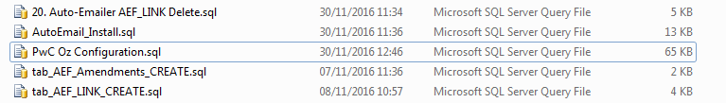

This data will/could include Autoemail template definition data, Autoemail configuration data and any other Autoemail specific data. CABS Autoemail should initially be configured as disabled.

Open the script file in MS SQL Server Management Studio, ensure that the connection is with the appropriate database and execute the script.

To check that the script has worked correctly use the CABS Console. In Descriptions and Codes,

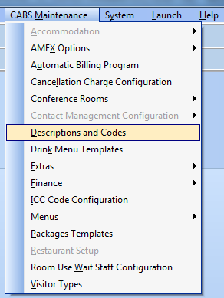

Ensure that an AutoEmail Template section exists:

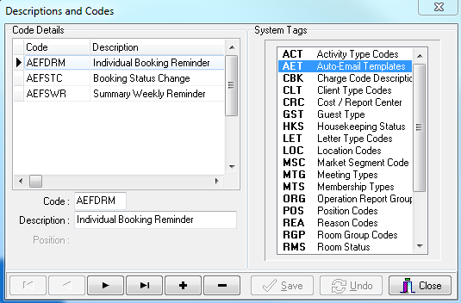
In System Defaults,

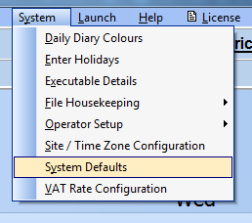

Ensure that the relevant sections have been added with the appropriate data:

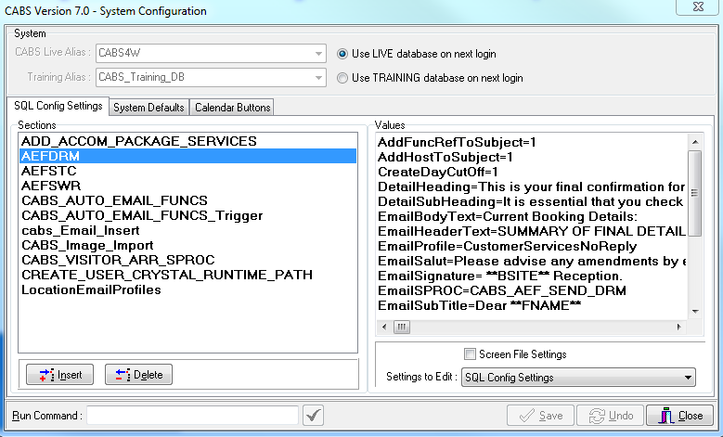

Run Query select * from vw_AEFLink

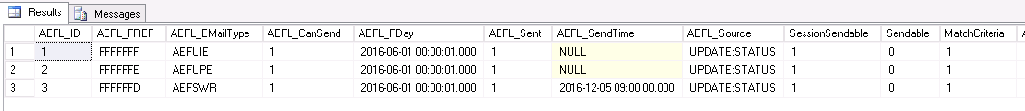

Email Address Changes for the Test Environment

Often databases used for testing and development are copies of a production system and as such will contain live databases. When testing CABS Autoemailer emails should not be sent to operational staff. To ensure that this potential issue is overcome any live email addresses should be replaced with test ones.
The following SQL will help to determine whether or not email changes have to be made on the test/development system:

SELECT * FROM OP_FILE WHERE O_EMAIL IS NOT NULL AND O_EMAIL <> ''
SELECT * FROM CONTACTS WHERE CT_EMAIL IS NOT NULL AND CT_EMAIL <> ''
SELECT * FROM MBRFILE WHERE MBR_EMAIL IS NOT NULL AND MBR_EMAIL <> ''
SELECT * FROM MBRFILE WHERE MBR_CEMAIL IS NOT NULL AND MBR_CEMAIL <> ''

If any emails need changing then run the following SQL

UPDATE OP_FILE SET O_EMAIL = '*** INSERT EMAIL ADDRESS ***'
WHERE O_EMAIL IS NOT NULL AND O_EMAIL <> ''

If the above query affects more than 1 record it may fail if the trigger OPERATOR_USER_LOG is enabled. In that instance, disable the trigger, run the query and then re-enable the trigger.

UPDATE CONTACTS SET CT_EMAIL = '*** INSERT EMAIL ADDRESS ***'
WHERE CT_EMAIL IS NOT NULL AND CT_EMAIL <> ''

UPDATE MBRFILE SET MBR_EMAIL = '*** INSERT EMAIL ADDRESS ***'
WHERE MBR_EMAIL IS NOT NULL AND MBR_EMAIL <> ''

UPDATE MBRFILE SET MBR_CEMAIL = '*** INSERT EMAIL ADDRESS ***'
WHERE MBR_CEMAIL IS NOT NULL AND MBR_CEMAIL <> ''

Email Profile Changes for the Test Environment

It maybe that Database Mail Email Profiles need to be changed for the test environment.

select * from xCABS_CONFIG_TABLE where SECTION = 'LocationEmailProfiles'

Location Extras

CABS AutoEmail Testing

Section CABS_AUTO_EMAIL_FUNCS_Trigger

Add DebugFlag=1
Change Enabled=0 to Enabled = 1

Section CABS_AUTO_EMAIL_FUNCS

Add DebugFlag=1
Change Enabled=0 to Enabled = 1

Check the following values to ensure settings are correct:

Company=Clayton Utz
AdminEmailAddr=tony.tasker@bcluk.com
CurrencySymbol=$
WIPWindow=0

Section AEFUPD

EmailProfile

Section AEFSWR

Add DebugSendDateTime=01/01/2016 00:00:01

ReportDurationInDays=7
ReportStartFromNowInDays=7
HyperLink1=http://www.bbc.co.uk

What was actually delivered was an email per site per booker

No booker email address

Section AEFDRM

For testing use
Frequency=D:0;H:0;M:1;W:1;L:CR;

Then replace with

FrequencyA=D:3;H:0;M:0;W:1;L:B4;

Table AutoEmailFunction

Once an autoemail has been sent the associated record in table AutoEmailFunction should be deleted. Any records remaining in this table can cause issue down the line.

SQL Agent Not Running – Jobs not running

Table AEF_LINK

For the AEFDRM email to work will need to get a record into aef_link for every function which has a function day in the future

